

**Vidyasagar University**

*For the partial fulfillment for the award of the degree of*

**Masters Of Computer Applications (M.C.A.)**

**Agrojira: Intelligent Crop Farming Management System**

Paper : MCA 491

Year Of Examination: 2025

Submitted By

**Surajit Maji**

Roll: VU/PG/100/23/32/02-IVS-0027

**Sreyashree Khanra**

Roll: VU/PG/100/23/32/02-IVS-0014

**Mamoni Sukla**

Roll: VU/PG/100/23/32/02-IVS-0004

Under the Supervision of

**Dr. Partha Chowdhuri**

Assistant Professor

**DEPARTMENT OF COMPUTER SCIENCE**

**VIDYASAGAR UNIVERSITY**

**MIDNAPORE, PASCHIMMEDINIPUR-721102,WESTBENGAL, INDIA**

Date of Submission:

**CERTIFICATE**

This is to certify that the software project titled **“Agrojira: Intelligent Crop Farming Management System”** has been successfully carried out by **Surajit Maji, Sreyashree Khanra** and **Mamoni Sukla**, students of **Vidyasagar University** under my supervision and guidance, in partial fulfillment of the requirements for the award of the degree of **Masters of Computer Application** from **Vidyasagar University.**This is to certify that the project entitled

I hereby declare that the work presented in this project is original and has been carried out by the students under my guidance. The content embodied in this project has not been submitted to any other institution or university for the award of any degree or diploma.

To the best of my knowledge, the project is an authentic piece of work and reflects the students’ understanding and application of the principles of software engineering, web development using Django, artificial intelligence integration (Dialogflow), and agricultural data management.

I take this opportunity to congratulate him for their sincere effort and wish him success in their future endeavors.

**______________________**

Signature of the Supervisor

**Dr. Partha Chowdhuri**

**Assistant Professor,**

**Department of Computer Science,**

**Vidyasagar University, Midnapore**

**Acknowledgement**

I would like to express my sincere gratitude to all those who have contributed directly or indirectly to the successful completion of my software project titled **“Agrojira: Intelligent Crop Farming Management System.”**

First and foremost, I extend my deepest thanks to **Dr. ­Partha Chowdhuri** , my respected project guide, for their constant encouragement, invaluable suggestions, and expert guidance throughout the development of this project. Their support played a crucial role in shaping this work from its conception to its final form.

I am also thankful to the **faculty members** of Department of Computer Science, Vidyasagar University for their constructive feedback and for providing me with the foundational knowledge that made this project possible.

A special note of thanks to my **friends and classmates** for their support, helpful discussions, and moral encouragement during the entire course of this project.

I am particularly grateful to the **farmers and agricultural experts** who provided domain-specific insights, helping me align the software with real-world farming practices and needs.

Finally,We also want to thank our parents, who taught us the value of hard work by their own example. We would like to share this moment of happiness with our parents. They rendered us enormous support during the whole tenure of our stay in Vidyasagar University, Midnapore, West Bengal. Finally; we would like to thank our department for giving us the opportunity and platform to make our effort a successful one.

----------------------------------

Signature Of the Students

**Surajit Maji**

**Sreyashree Khanra**

**Mamoni Sukla**

**Abstract**

Agriculture is the backbone of many economies, yet farmers often face significant challenges due to a lack of access to timely and accurate information, scientific farming techniques, and expert guidance. To bridge this gap, the project titled **“Agrojira: Intelligent Crop Farming Management System”** has been developed as a comprehensive, AI-integrated web application aimed at assisting farmers in managing their crop cultivation efficiently and intelligently.

Agrojira leverages modern technologies such as Django for backend development, MySQL for data management, and Dialogflow for natural language understanding to offer a user-friendly interface for both novice and experienced farmers. The system is structured around the complete crop lifecycle, comprising modules for soil preparation, sowing, irrigation, fertilization, pest and disease management, weed control, harvesting, and post-harvesting. Each module allows farmers to input real-time data, receive expert suggestions, upload images, and track their project's progress.

A key highlight of Agrojira is its integration of machine learning models and expert system rules to provide predictive analytics and intelligent recommendations tailored to crop type, region, and farming practices. Furthermore, the chatbot powered by Dialogflow enables natural language interactions, allowing users to ask questions and receive instant support, making agricultural knowledge more accessible.

The system also supports role-based access for farmers, expert farmers, and administrators, ensuring that personalized recommendations, expert feedback, and administrative controls are efficiently managed. With a focus on scalability, modularity, and ease of use, Agrojira aims to revolutionize traditional farming by promoting digital agriculture, reducing crop loss, and improving productivity.

In conclusion, Agrojira represents a significant step toward smart and sustainable farming by empowering farmers with technology-driven solutions and expert insights.

**Table of Contents**

Contents

1. Introduction 6

2. Literature Review / Related Work 9

Summary of Existing Work 9

Contribution of Agrojira 10

3. Methodology 11

Tools and Technologies Used: 11

Project Design / Architecture 11

Implementation Steps: 12

Data Collection Methods: 12

4. System Design/ Development 14

5. Result and Discussion 49

6. Conclusion 56

7. Future Work 58

8. References 60

# 1. Introduction

Agriculture is a critical sector that supports the livelihood of millions of people, especially in rural regions. Despite technological advancements, many farmers—particularly beginners—continue to struggle due to lack of proper guidance, un-optimized resource use, and limited access to expert knowledge. Traditional farming practices are often not aligned with modern agricultural demands, and climate uncertainty further aggravates the challenges faced by farmers.

To address these issues, the **Agrojira: Intelligent Crop Farming Management System** has been conceptualized as a comprehensive software platform that empowers farmers through digital tools, expert support, and intelligent decision-making. It combines modern technologies such as Artificial Intelligence (AI), Natural Language Processing (NLP), and potential future to enhance agricultural productivity and promote smart farming practices. The system is built to guide farmers through each step of the crop lifecycle—right from soil preparation to harvesting and storage—providing real-time insights, recommendations, and interactive learning resources.

**Background of the Study**

India, and many other agricultural nations, is home to a large population of beginner and small-scale farmers who lack access to formal agricultural education or digital support. These farmers often rely on outdated practices or inconsistent information, which leads to poor crop yields, resource wastage, and financial instability. Current agricultural applications are either too complex, inaccessible due to internet limitations, or fail to provide localized and personalized farming support.

Key challenges faced include:

* **Lack of Knowledge:** New farmers struggle with understanding how to select crops, manage soil health, and handle pests, weeds, and diseases.
* **Un-optimized Resource Use:** Incorrect application of water, seeds, and fertilizers results in lower yield and wasted resources.
* **Limited Expert Access:** In remote and rural areas, direct access to agronomists or expert guidance is minimal.
* **Climate Uncertainty:** Sudden weather changes can damage crops, and farmers often lack tools for prediction and adaptive strategies.
* **Low Tech Adoption:** Many existing solutions require constant internet connectivity and are not user-friendly for non-technical users.

Agrojira addresses these problems by offering a user-friendly, intelligent, and scalable platform that serves as a one-stop solution for modern farming needs.

**Objectives of the Project**

The primary objective of the **Agrojira** project is to create a digital platform that supports beginner and semi-skilled farmers throughout the entire farming lifecycle using AI, expert advice, and smart tools.

Specific objectives include:

* To provide **step-by-step guidance** on the entire crop process: from soil preparation to post-harvest storage.
* To offer **crop and resource recommendations** based on soil type, climate, and regional practices.
* To enable **AI-based detection of pests and diseases** through image uploads and pattern recognition.
* To facilitate **real-time expert consultation**, emergency alerts, and a community learning space.
* To preserve traditional agricultural wisdom by digitizing and integrating it with modern technology .
* To support **multi-role access** for Farmers, Expert Farmers, and Admins with personalized dashboards and data scopes.

**Scope of the Project**

The project is designed to evolve in **phases**, starting with the essential features in the **Minimum Viable Product (MVP)** and progressively expanding into advanced functionalities.

**Phase 1 – MVP (Core Features):**

* AI-powered crop and soil suitability analysis
* Step-by-step farming modules (soil, sowing, irrigation, fertilization, harvesting)
* Image and multimedia-based tutorials
* Community support and forum

**Phase 2 – Advanced Features:**

* AI-driven pest and disease detection using uploaded crop images
* Live expert support and virtual consultation features
* Real-time progress tracking and analytics dashboard

**Phase 3 – Expansion & Market Integration:**

* Augmented Reality (AR) based training and simulation modules
* Dialogflow-powered chatbot assistance for real-time Q&A

**Expected Outcomes:**

* Improved decision-making and crop yield for beginner farmers.
* Reduced crop failure through intelligent recommendations and expert feedback.
* Increased technology adoption in rural agriculture.
* A digitally connected farming community with shared learning and collaboration.

# 2. Literature Review / Related Work

In recent years, significant progress has been made in the domain of smart agriculture through the integration of digital tools, artificial intelligence, and expert systems. Various software platforms and mobile applications have emerged to aid farmers in decision-making, crop selection, pest control, and resource management. However, the majority of these solutions either lack contextual relevance for beginner farmers or are not comprehensive in covering the entire agricultural lifecycle.

### Summary of Existing Work

Several smart farming platforms currently in use include:

* **mKisan Portal (India)** – A government initiative that provides farmers with SMS-based information related to crop advisories, weather, and market prices. However, it lacks interactivity and real-time expert guidance.
* **Kisan Suvidha App** – Offers weather forecasts, market prices, plant protection details, and expert advisories. While useful, it does not offer personalized, stage-wise guidance.
* **Plantix** – A mobile app offering AI-based plant disease detection using image recognition. It focuses mainly on diagnosis and less on the holistic farming process.
* **IBM Watson Decision Platform for Agriculture** – An enterprise-level solution using satellite data, AI, and IoT. Its complexity and cost make it inaccessible for smallholder or beginner farmers.

These platforms provide valuable features but tend to specialize in isolated parts of the farming process, such as disease detection, weather updates, or market connectivity.

**Key references**

1. “A Survey and Analysis of Various Agricultural Crops Classification Techniques” - by

Surabhi Chouhan, Divakar Singh, Anju Singh

2. “SOIL ANALYSIS AND CROP FERTILITY PREDICTION USING MACHINE LEARNING” – by Jagdeep Yadav, Shalu Chopra, Vijayalakshmi M

3. “Smart farming using Machine Learning and Deep Learning techniques” – by Senthil Kumar Swami Durai , Mary Divya Shamili

4. “International Journal of Engineering Applied Sciences and Technology “ -by Devdatta A. Bondre, Mr. Santosh Mahagaonkar

**Gaps identified**

Despite the availability of multiple agricultural apps and platforms, several gaps remain that directly affect beginner farmers:

* **Lack of End-to-End Solutions**: Most platforms address only one or two aspects of farming. There is a need for a system that covers all stages—from soil preparation to post-harvesting.
* **No Step-by-Step Guidance**: Beginner farmers need actionable, stage-wise farming instructions, which are often missing in existing tools.
* **Low Accessibility**: Many applications are not optimized for low-bandwidth or offline environments, excluding farmers in remote areas.
* **Limited Interactivity**: Current tools often do not include chatbot interfaces or natural language interaction, making them less intuitive for non-tech-savvy users.
* **Weak Community Integration**: There is little emphasis on community learning and farmer-to-farmer support in existing systems.

### Contribution of Agrojira

**Agrojira** is designed to bridge these gaps by providing:

* A full-cycle, stage-wise farming assistant
* AI-based decision support with offline capabilities
* Dialogflow-powered chatbot for user-friendly interaction
* Community forums for shared learning

By integrating modern technologies with practical field knowledge and a focus on accessibility, Agrojira aims to be an inclusive, intelligent, and farmer-friendly platform that modernizes and simplifies farming for all.

# 3. Methodology

The development of **Agrojira: Intelligent Crop Farming Management System** follows a modular and iterative methodology using modern web development frameworks, intelligent system integration, and user-focused design. The project is structured to ensure scalability, maintainability, and efficient interaction among different user roles: Farmer, Expert Farmer, and Admin.

### Tools and Technologies Used:

| **Category** | **Tools & Technologies** |
| --- | --- |
| Backend Framework | Django (Python) |
| Database | MySQL (via X hosted server) |
| Frontend Technologies | HTML5, CSS3, JavaScript, AJAX |
| Styling & Responsiveness | Bootstrap (initially) |
| AI/NLP Integration | Dialogflow (Google) |
| Deployment & Hosting | PythonAnywhere / Localhost with Ngrok |
| Additional Tools | Google Colab (for AI model training if needed) |

### Project Design / Architecture

Agrojira follows a **three-tier architecture**:

**i. Presentation Layer (Frontend):**

* Handles user interactions via forms, tables, and visual components.
* Provides role-specific dashboards for Farmers, Expert Farmers, and Admins.
* Includes chatbot UI for natural language queries.

**ii. Application Layer (Backend Logic):**

* Built using Django's MVC (Model-View-Controller) structure.
* Processes user requests, handles business logic, and manages data storage.
* Integrates Dialogflow webhook to serve intelligent responses.

**iii. Data Layer (Database):**

* Stores all crop information, farming stages, user details, and expert suggestions.
* Each farming stage is linked to the farmerProject model using foreign keys.
* ML predictions, images, and expert feedback are stored with status tracking.

### Implementation Steps:

1. **Requirement Analysis**
   1. Studied the real-world challenges faced by beginner farmers.
   2. Identified essential features for MVP and future expansion.
2. **Database Design**
   1. Created normalized Django models: farmerProject, adminCrop, and 11 stage models (soil, sowing, irrigation, etc.).
   2. Defined role-based user models and authentication.
3. **Frontend Development**
   1. Designed responsive forms for each crop stage with image upload and preview.
   2. Created dynamic templates for viewing, updating, and tracking progress.
4. **Backend Development**
   1. Developed Django views for CRUD operations.
   2. Integrated AI predictions, form validation, and expert suggestion handling.
5. **Chatbot Integration (Dialogflow)**
   1. Created intents like GetCropInformation, AskExpert, TrackProgress.
   2. Developed webhook in Django to receive queries and return context-specific responses.
   3. Embedded the chatbot into the frontend via iframe or widget.
6. **Multimedia Content**
   1. Linked video tutorials to stages for learning.
   2. Supported community content like expert posts and user feedback.
7. **Testing and Validation**
   1. Unit testing of forms and views.
   2. Functional testing of the chatbot and prediction logic.
   3. Real-time testing using sample farmer data.

### Data Collection Methods:

The project uses both **primary** and **secondary data** for system accuracy and intelligence:

#### Primary Data:

* Form inputs provided by farmers (crop type, soil info, irrigation data, etc.).
* Images of plants, soil, and pests uploaded by users for AI analysis.
* Expert feedback entered through a dedicated dashboard.

#### Secondary Data:

* Public datasets on soil types, fertilizers, and pest information.
* Agricultural reports and research papers for rule-based logic.
* API sources for weather updates and market prices (for future integration).

The methodology adopted for Agrojira emphasizes modularity, intelligent automation, and accessibility for rural farmers. Through a combination of Django-powered backend, AI-driven chatbot, and rich multimedia support, Agrojira provides a practical and intelligent solution for modern agriculture.

# 4. System Design/ Development

**i. ER Diagram:**

* Main Model: farmerProject
* Linked via FK to 11 models: farmerSoil, farmerSowing, farmerIrrigation, farmerFertilizer, farmerWeed, farmerPest, farmerDisease, farmerHarvesting, farmerPostHarvesting, farmerOthers, expertVideo

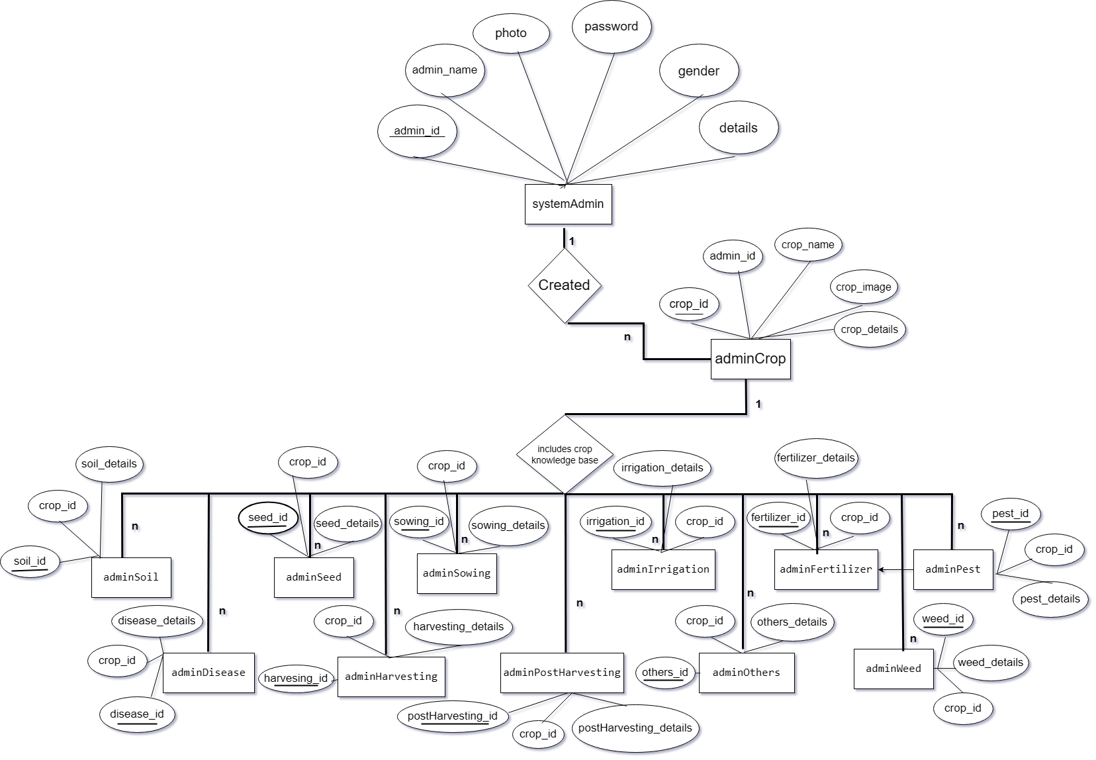

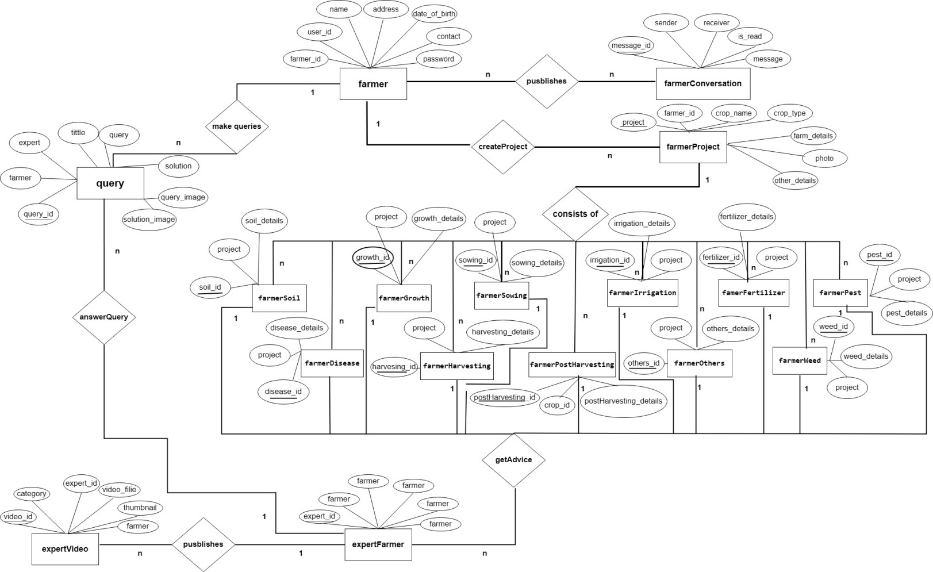

**A. Use Case Diagram:**

* **Actors:** Farmer, Expert Farmer, Admin
* **Use Cases:**
  + Register/Login
  + Create/Update/View Farming Project
  + Add/View Suggestions (Expert)
  + Upload Stage-wise Data (Farmer)
  + View AI Predictions
  + Chatbot Assistance (All Users)
  + Manage Crops & Users (Admin)

**B. Flowchart: Farming Stage Submission**

1. User logs in
2. Selects project
3. Chooses stage (e.g., Soil, Irrigation)
4. Inputs details + uploads image
5. Submits form
6. Data saved to database
7. AI or expert feedback added

**C. Wireframe Concepts (Frontend Pages):**

* Login Page
* Dashboard (Farmer/Expert/Admin)
* Stage Submission Form
* Stage Overview with Suggestions & Predictions
* Chatbot Popup Interface

**ii. Database Tables**

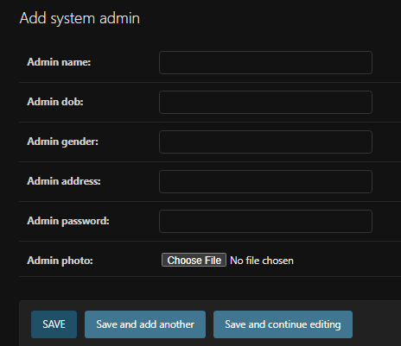

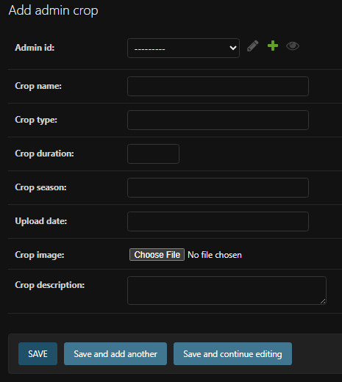

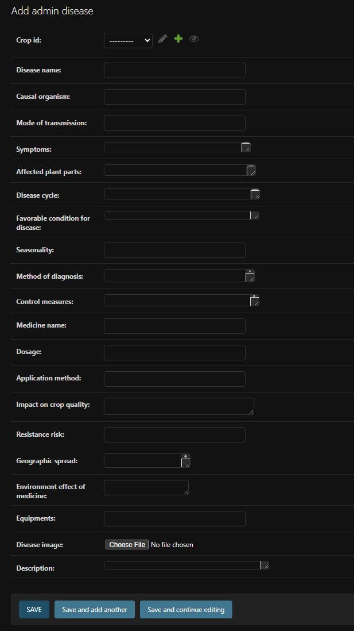

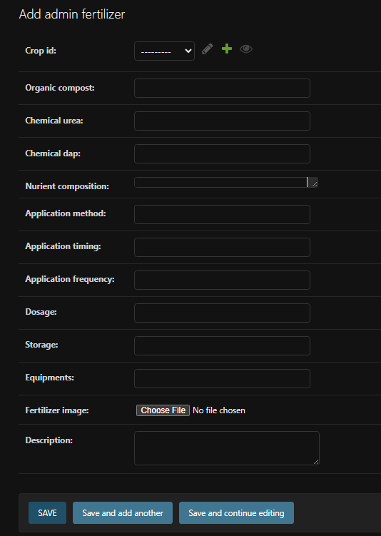

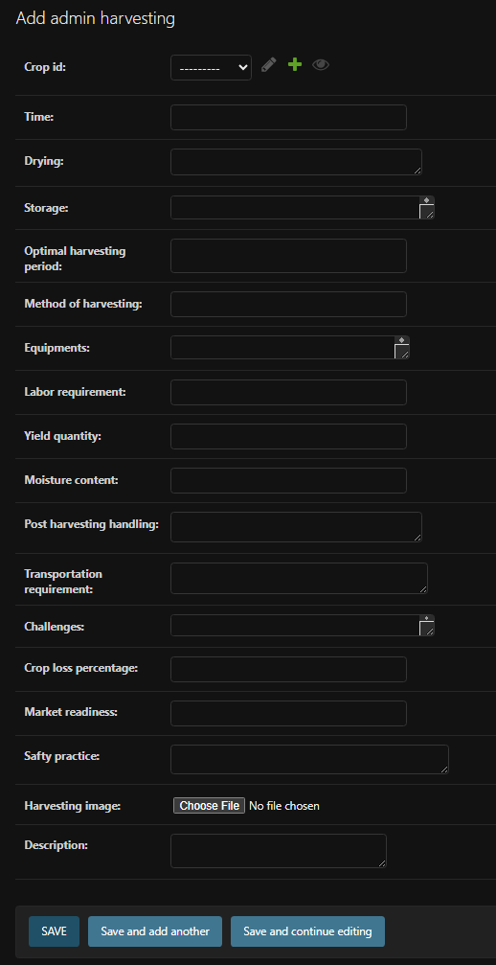

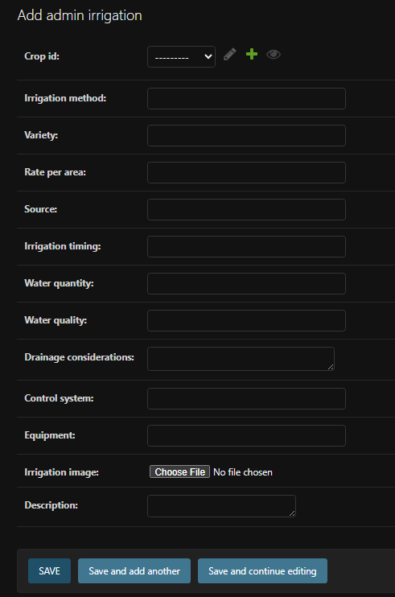

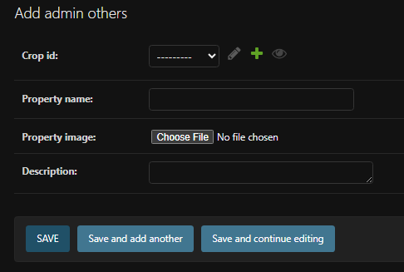

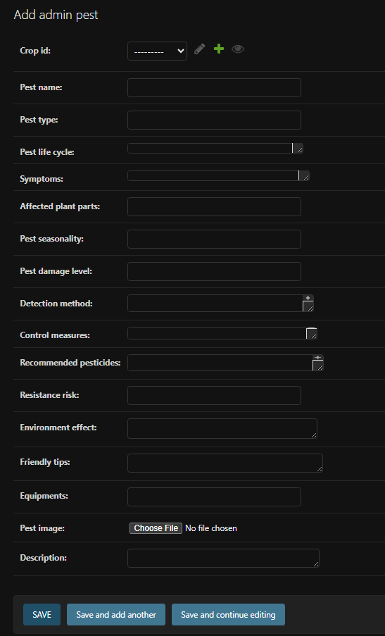

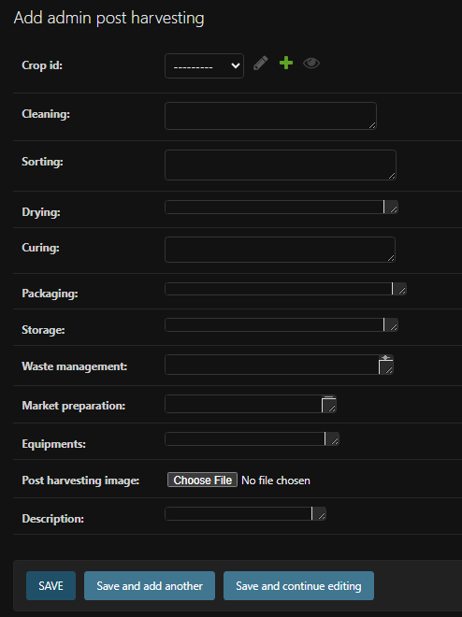

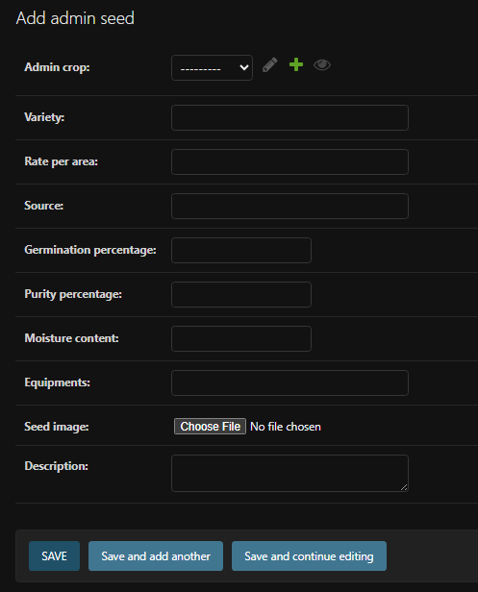

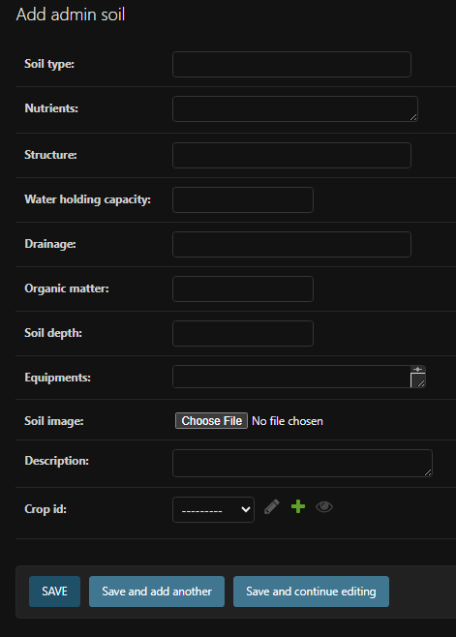

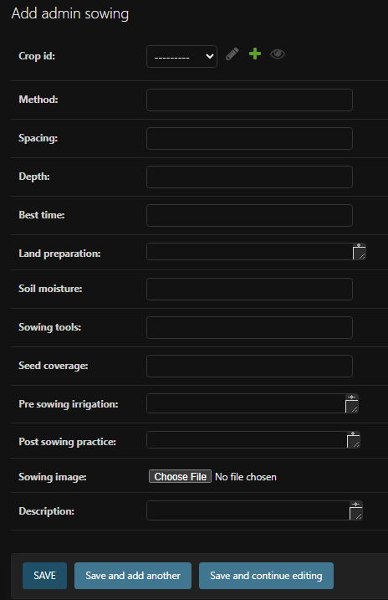

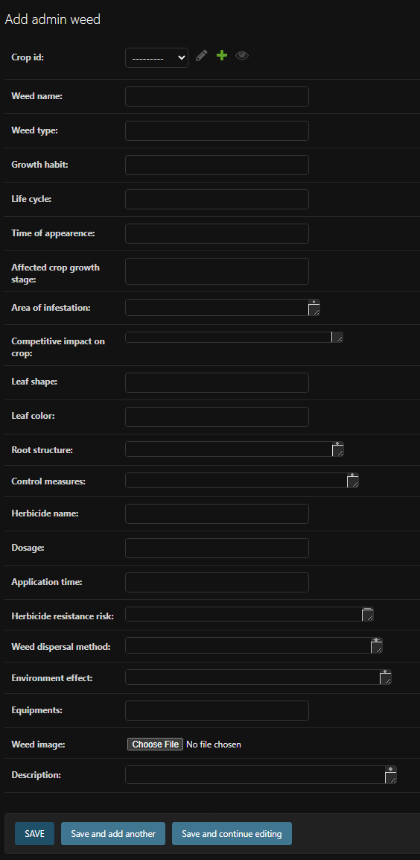

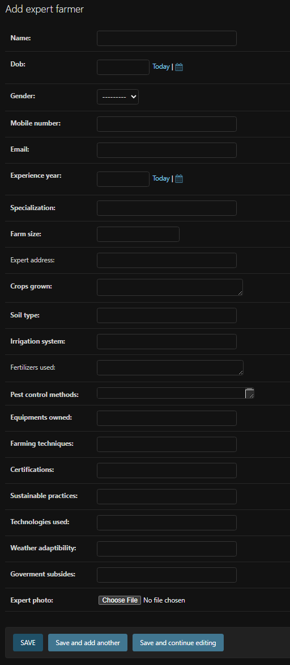

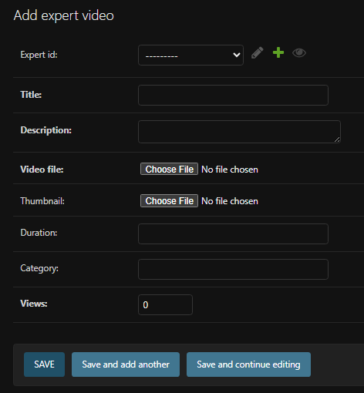

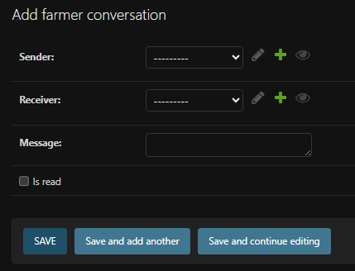

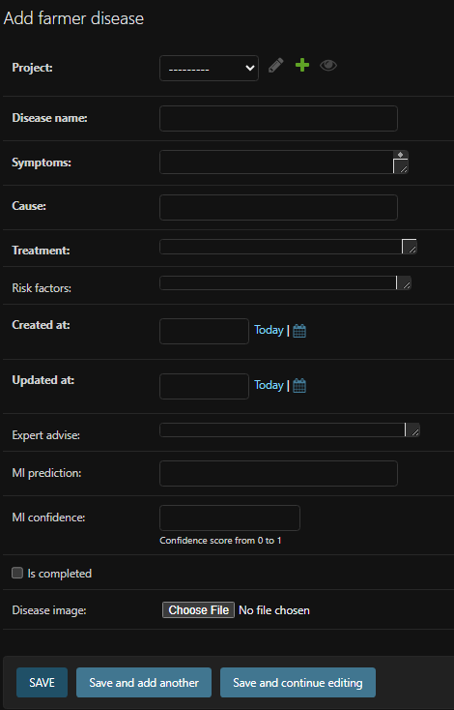

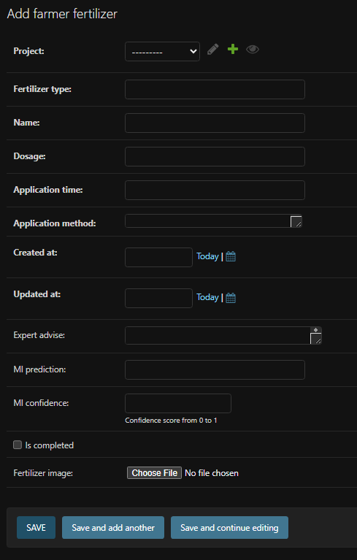

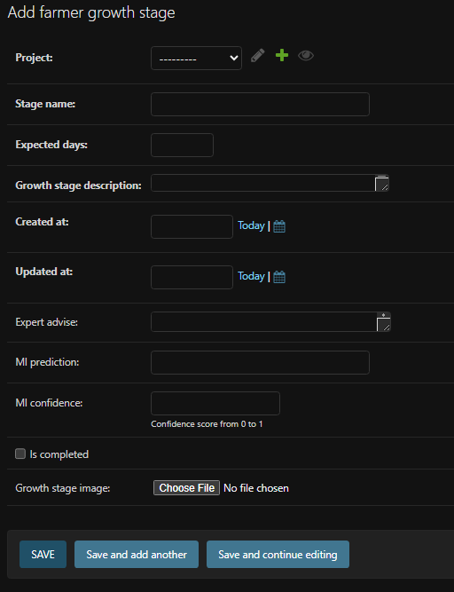

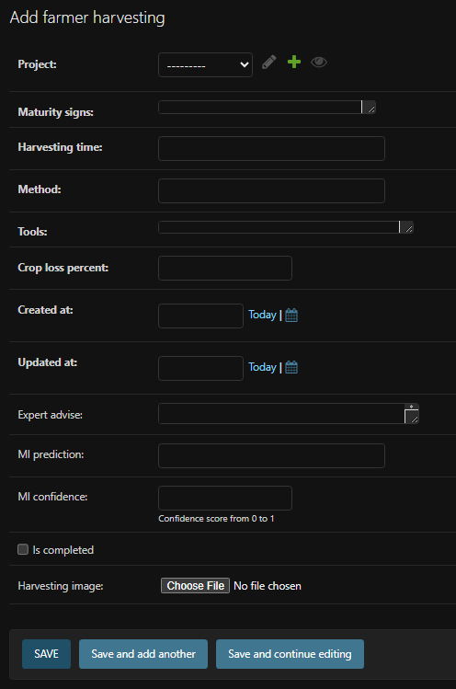

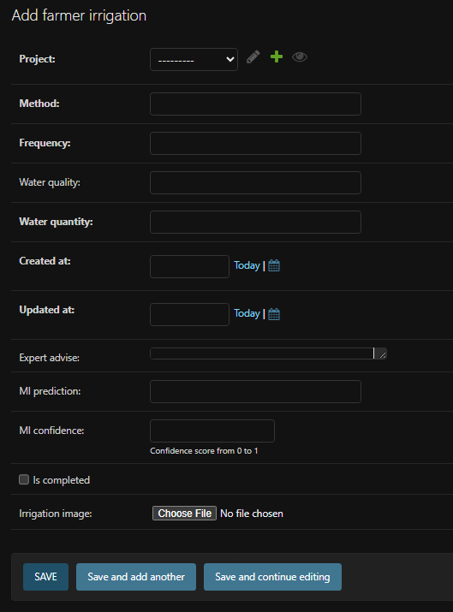

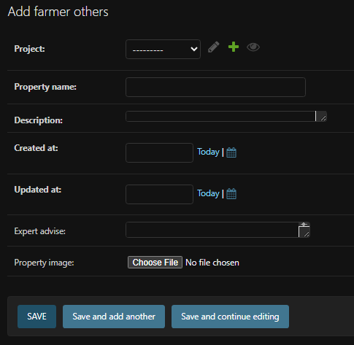

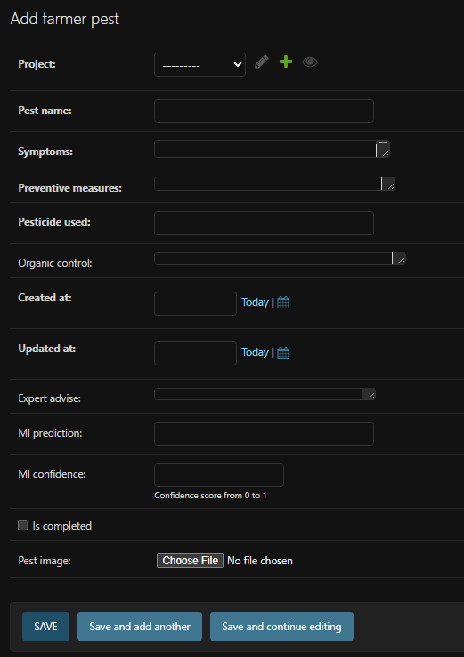

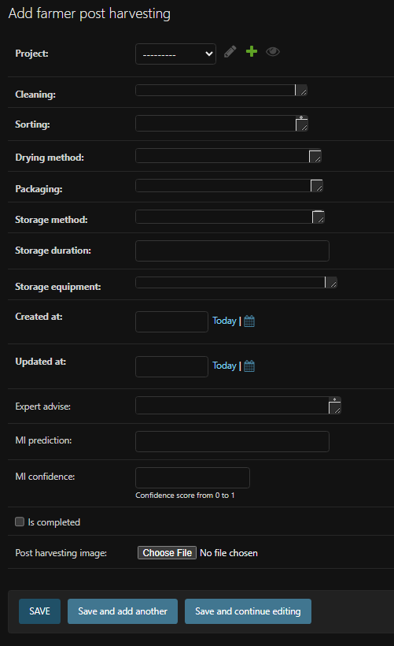

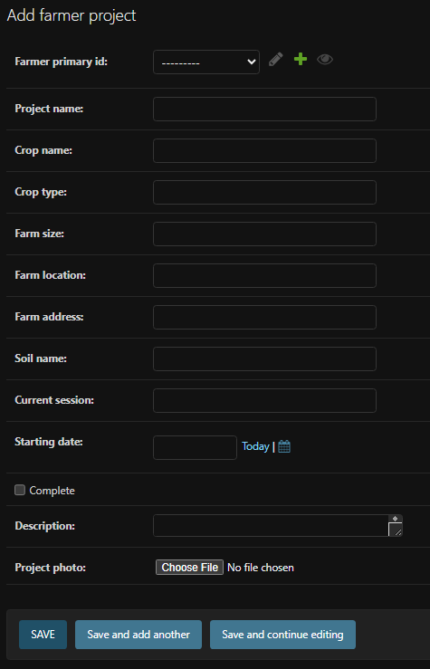

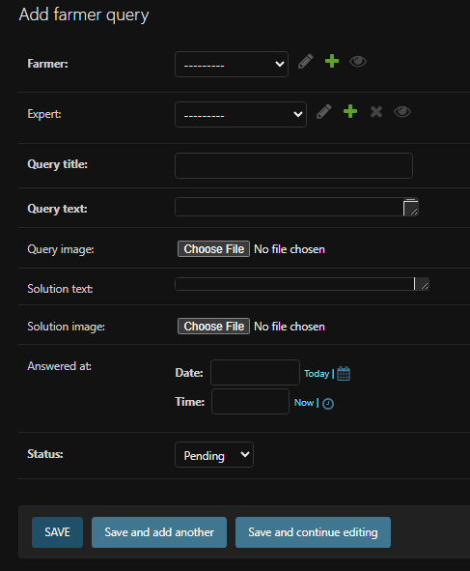

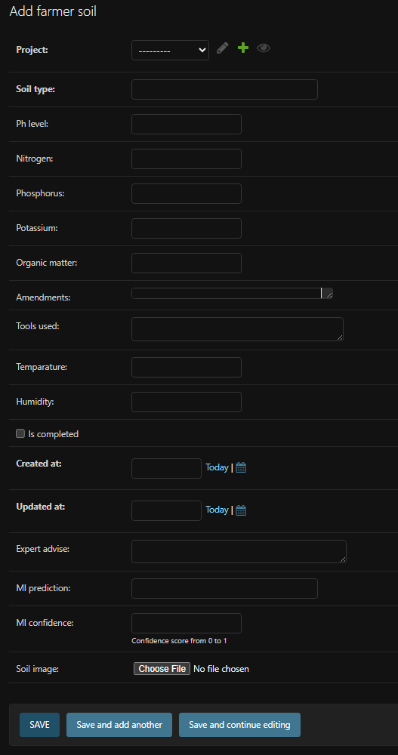

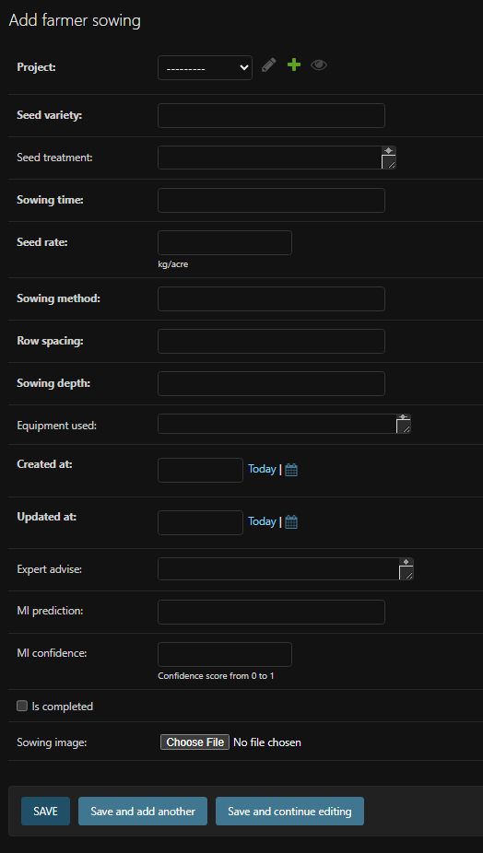

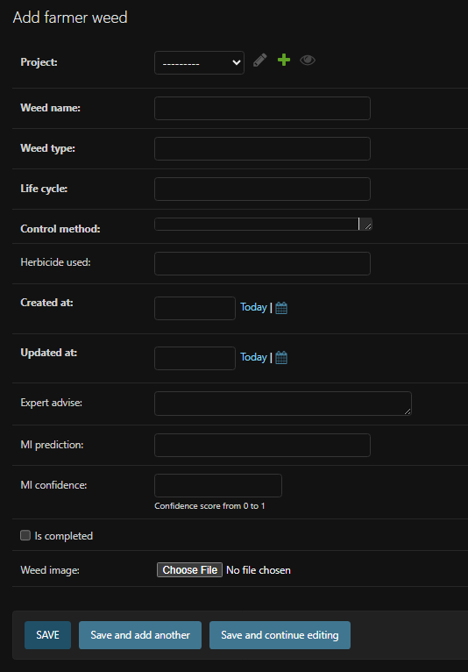

**iii. Database Schema (Simplified)**

* **User** (Custom user model)
  + id, username, password, role (Farmer/Expert/Admin)
* **adminCrop**
  + id, crop_name, description, soil_type, suitable_weather
* **farmerProject**
  + id, user (FK), crop (FK), start_date, status, ai_progress
* **farmerSoil / Sowing / Irrigation / etc.** (One model per stage)
  + id, project (FK), inputs, image, completion_status, expert_comment, ai_suggestion
* **expertVideo**
  + id, expert (FK), title, video_file, stage_related
* **chatbotQueryLog**
  + id, user (FK), query_text, response_text, timestamp

**iv. Modules and Their Functionalities**

1. **Authentication Module**
   * Role-based login and session management
   * Registration and password security
2. **Crop Management (adminCrop)**
   * Admin adds/edit crops and metadata
   * Referenced by farmer projects
3. **Project Management (farmerProject)**
   * Farmers create a new project
   * Link with crop, assign timeline and track stage completion
4. **Farming Stages Modules**
   * Each stage (e.g., Soil, Irrigation) has a dedicated model and form
   * Image upload, user input, AI/Expert comment, status tracking
5. **Expert Support Module**
   * Experts view submitted data, add suggestions
   * Can upload tutorial videos
6. **AI Prediction Module**
   * Integrates with ML models for stage suggestions or image-based diagnosis
   * Returns AI-generated advice to farmer’s dashboard
7. **Chatbot Module (Dialogflow Integration)**
   * Responds to natural language queries
   * Uses webhook to fetch crop data, guide users, and interact contextually
8. **Community Module (Future Extension)**
   * Forum for question-answer between farmers and experts
9. **Offline Sync (Future Feature)**
   * Allow users to download guides and sync data once online

**v. Data Flow Diagram:**

**Level 0:**

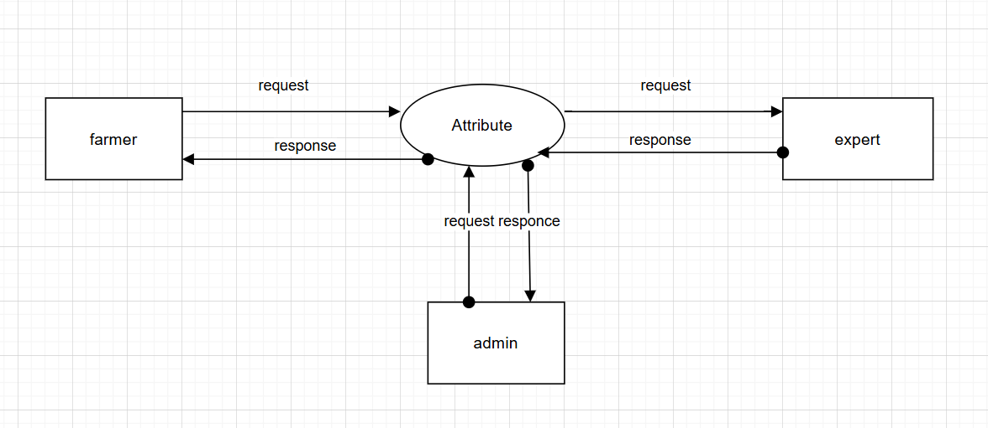

**Level 1:**

**ADMIN:**

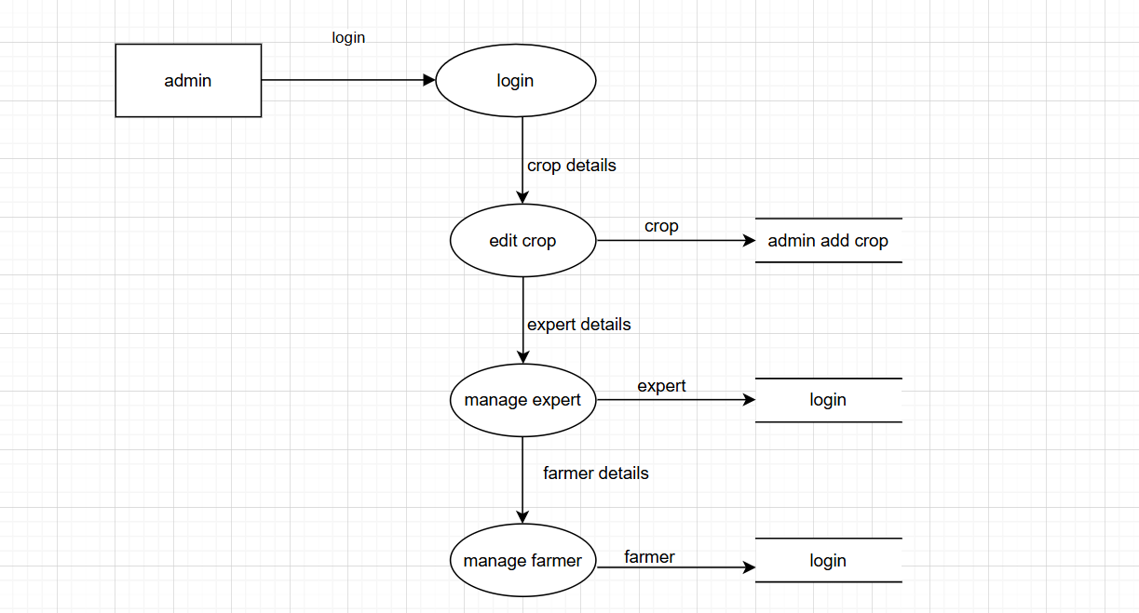

**FARMER:**

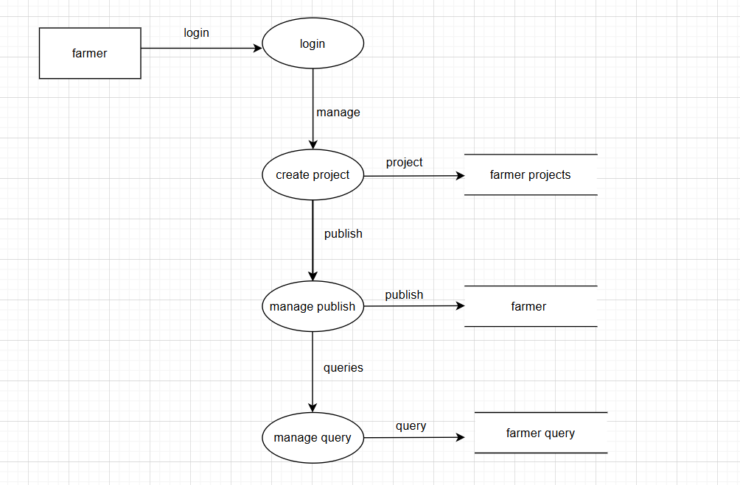

**EXPERT:**

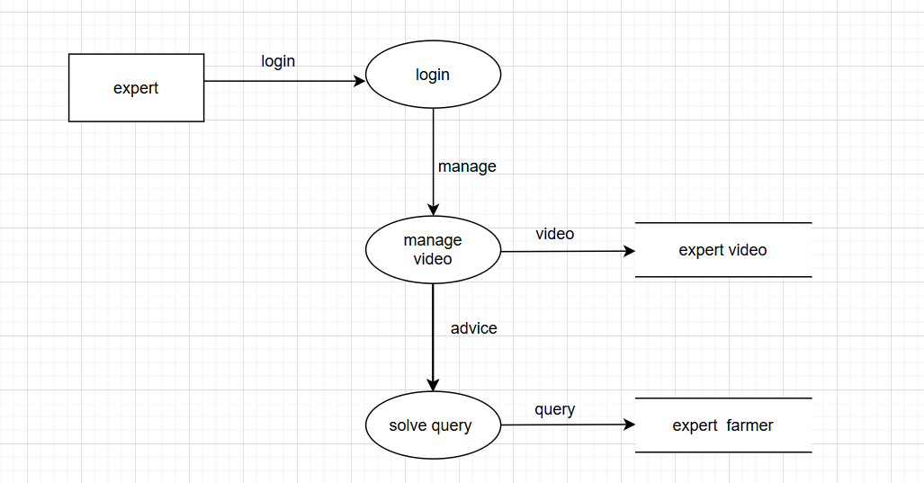

**LEVEL 2:**

**ADMIN:**

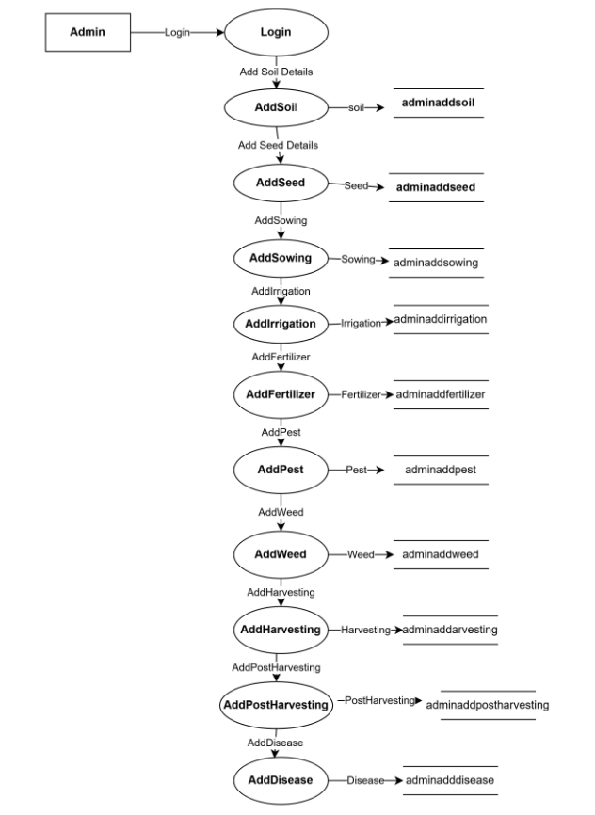

**FARMER:**

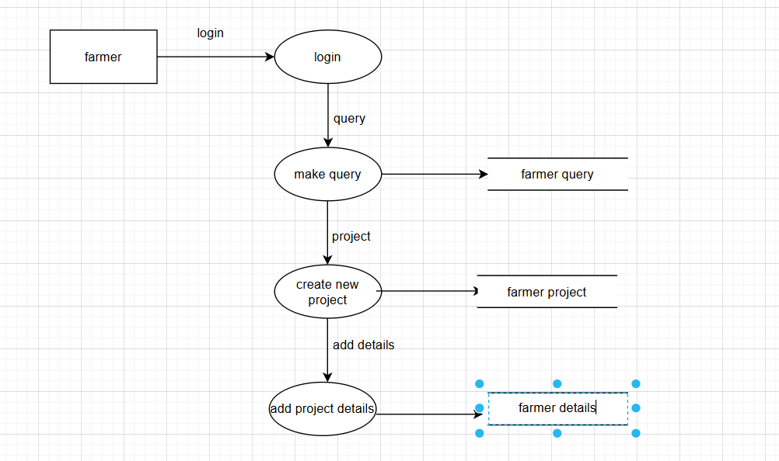

**EXPERT:**

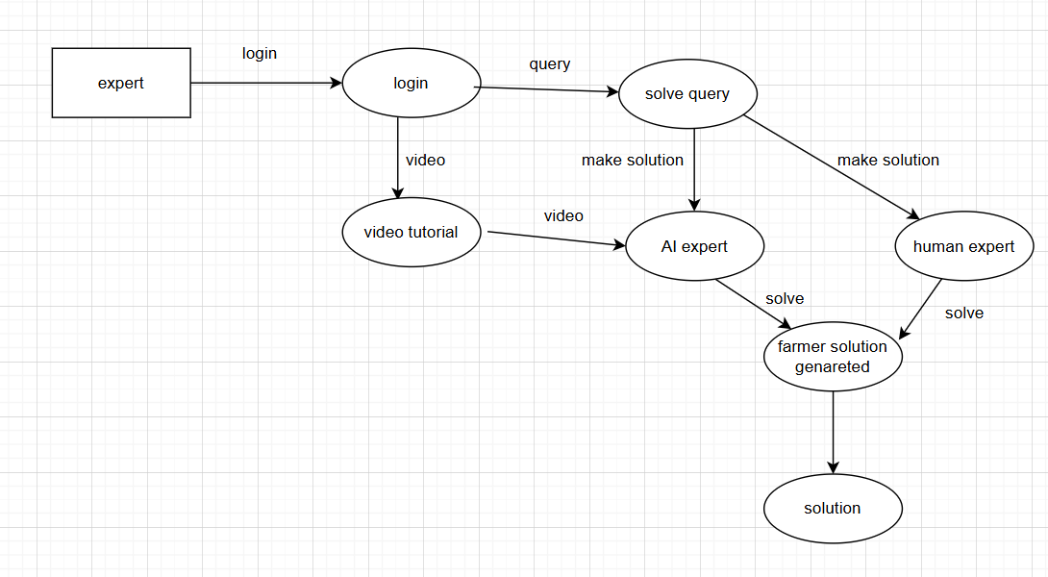

# 5. Result and Discussion

#### Output Screenshots or Results

Agrojira was successfully developed as a web-based intelligent crop management system with the following functional results:

1. **User Registration & Role Management**

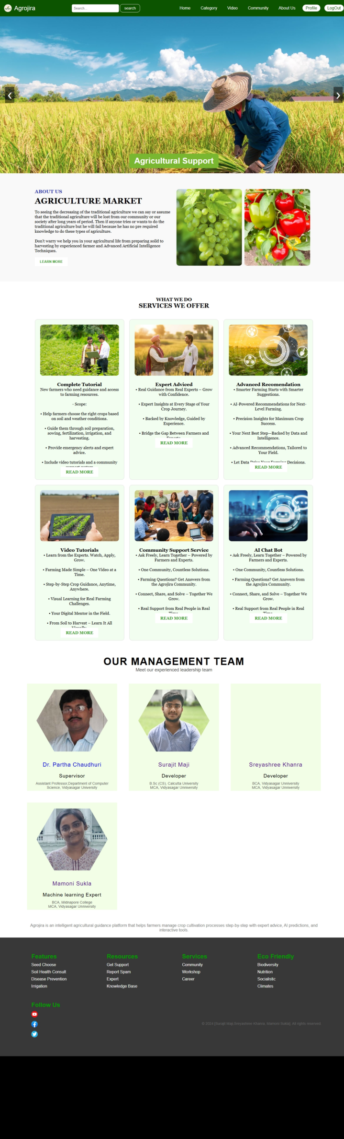

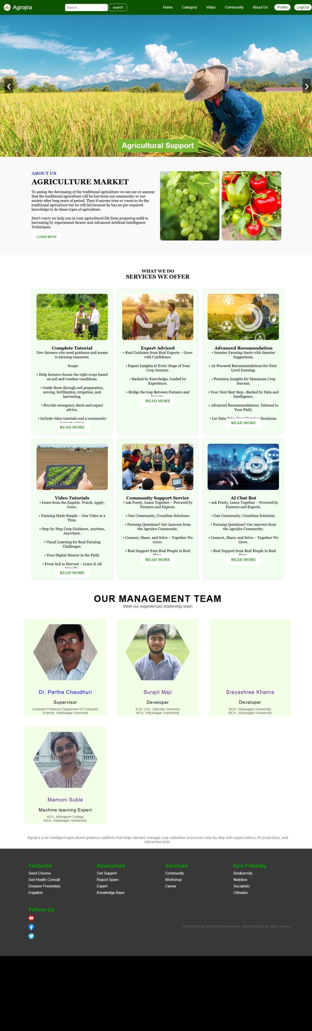

* + Separate login/signup interfaces for Farmers, Expert Farmers, and Admins.

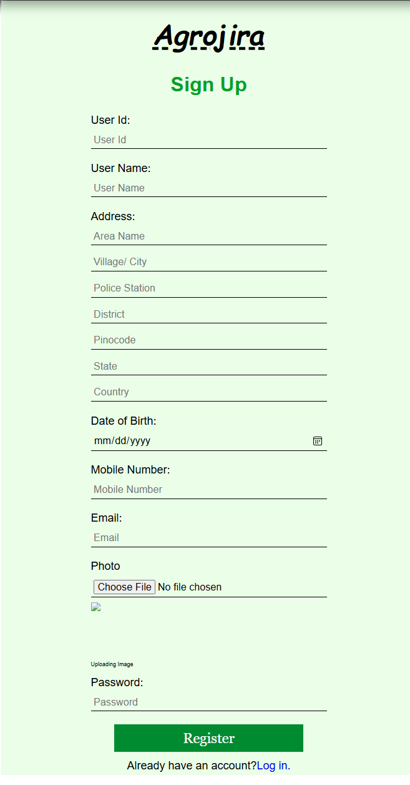

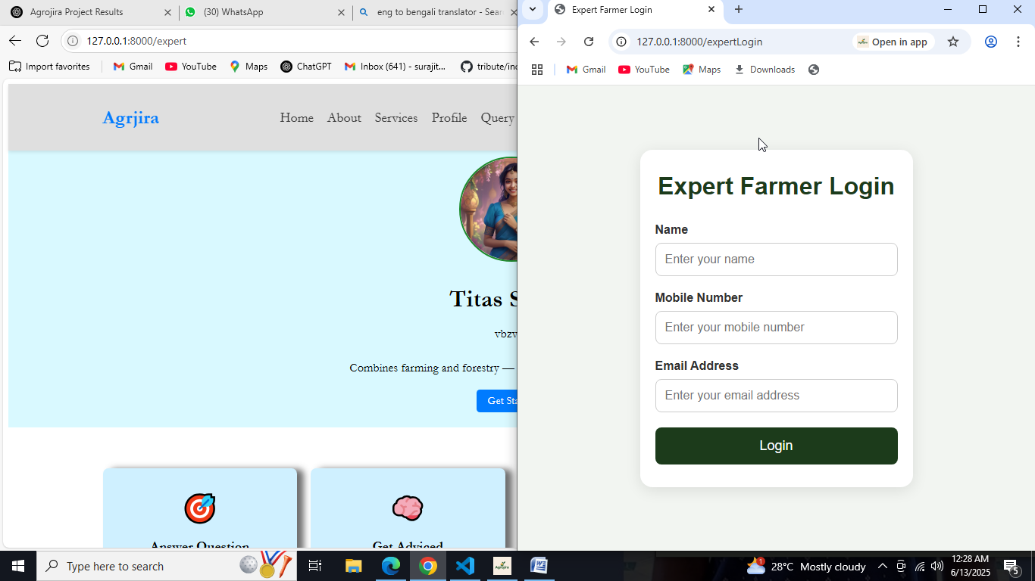

* + Role-based dashboard redirection and access control.

1. **Dynamic Farming Stage Management**
   * Farmers can create and update crop projects through 11 intelligent stages (Soil, Sowing, Irrigation, etc.).  
     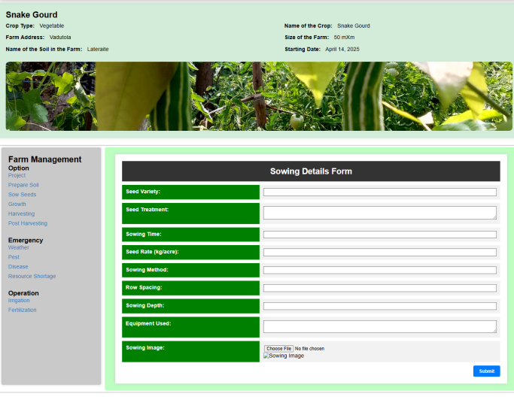
   * Each stage has an input form with image upload, expert suggestions, ML predictions, and completion status.

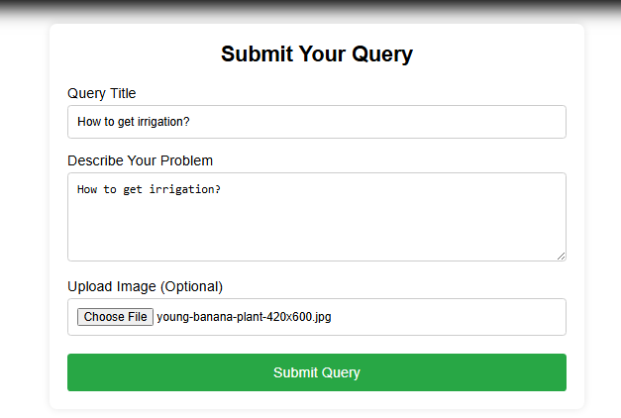

* + Output shows individual progress per stage, AI recommendations, and expert comments.  
    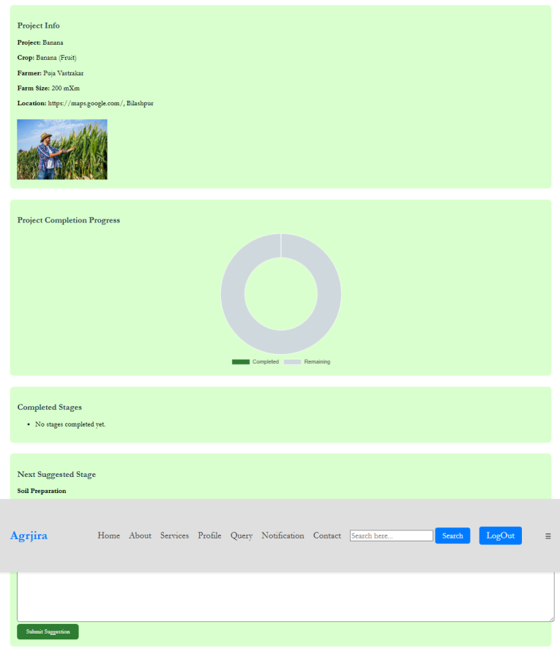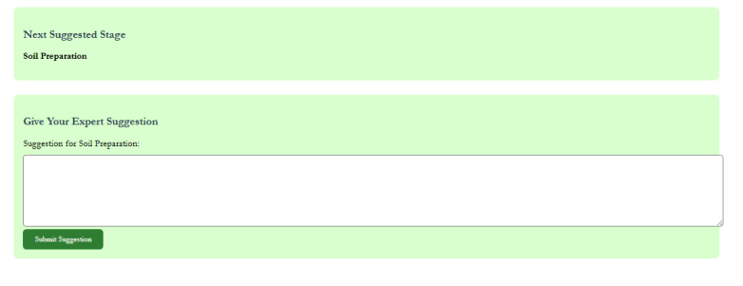

(Replace with actual screenshot)

1. **Expert Recommendations & AI Integration**
   * Dialogflow-integrated chatbot provides intelligent answers to crop queries.  
     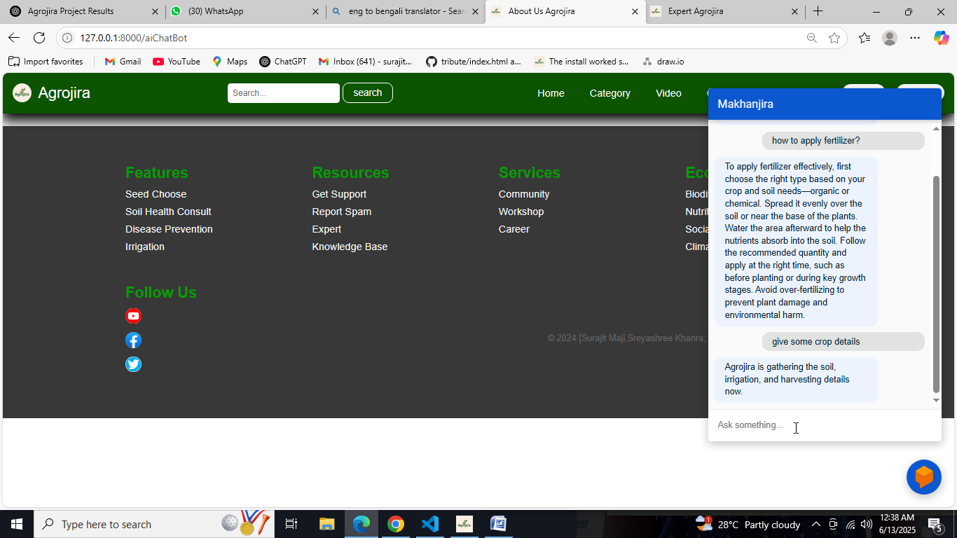
2. **Crop Search & Knowledge Base**
   * Farmers can search for crop-specific guidance (e.g., Wheat) and get results from multiple admin models.

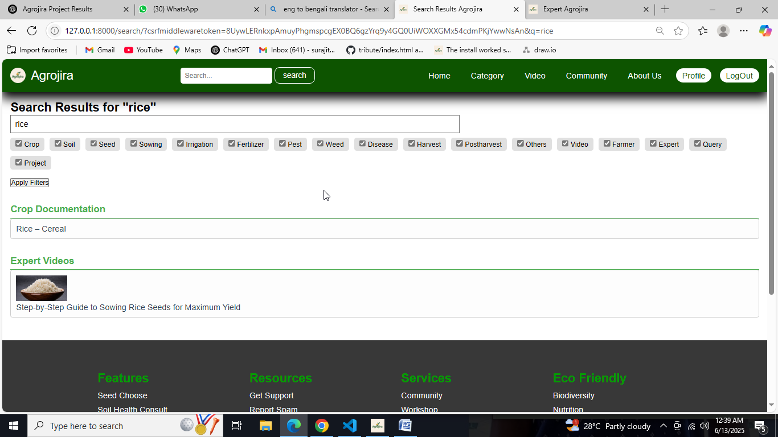

* + Thumbnails for expert-uploaded videos auto-play on hover.

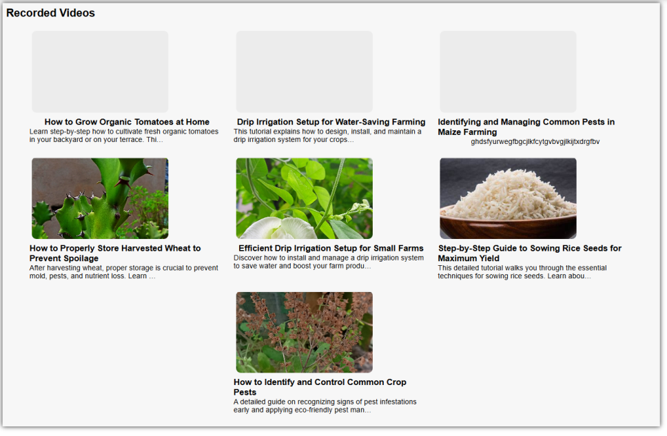

1. **Project Tracking and Visualizations**
   * Visual pie chart of stage-wise completion.

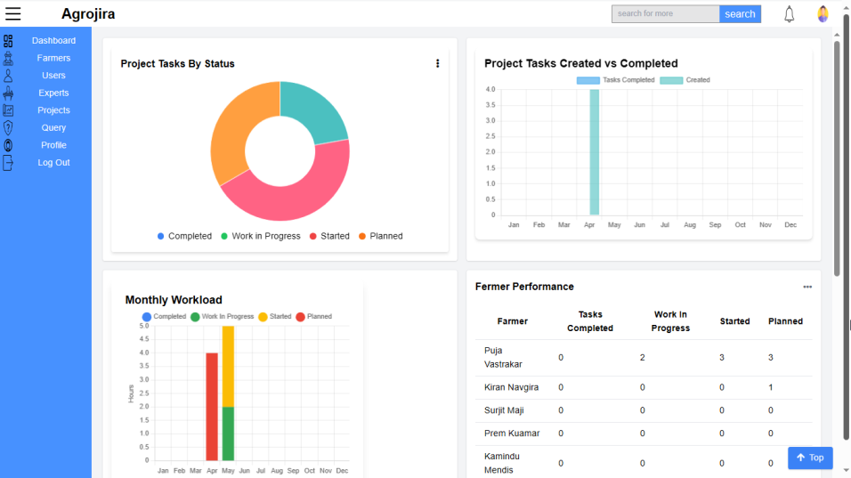

vi. **Machine Learning Prediction System Integration**

To enhance decision-making in modern agriculture, Agrojira integrates three intelligent prediction modules powered by Machine Learning. These modules assist farmers with real-time, data-driven recommendations for crop selection, fertilizer usage, and pest control, based on soil and environmental parameters.

1. **Crop Recommendation Module**
   1. **Objective**: Suggest the most suitable crop based on soil nutrients and environmental factors.
   2. **Input Parameters**:
      1. Nitrogen (N), Phosphorous (P), Potassium (K)
      2. Temperature (°C)
      3. Humidity (%)
      4. Soil pH
      5. Rainfall (mm)
   3. **ML Model**: Trained using Naive Bayes model on publicly available crop datasets.
   4. **Functionality**:
      1. Takes inputs from the user via a frontend form.
      2. Predicts the most suitable crop using pre-trained ML models.
      3. Displays the recommended crop name instantly.
   5. **Use Case**: Helps beginner farmers choose the best crop for their specific land and climate conditions, improving yield and sustainability.

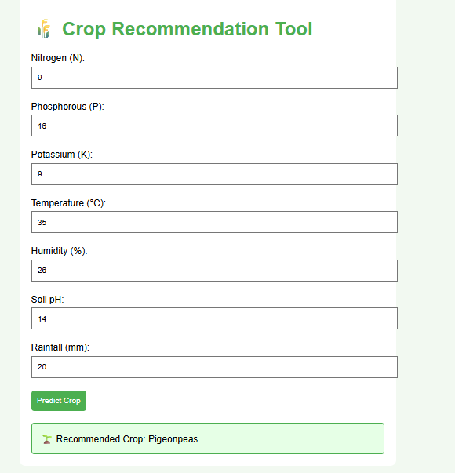

1. **Fertilizer Recommendation Module**
   1. **Objective**: Suggest optimal fertilizers and their compositions based on soil nutrients and crop requirements.
   2. **Input Parameters**:
      1. Temperature (°C), Humidity (%), Moisture (%)
      2. Soil Type
      3. Crop Type
      4. Current soil nutrient levels: Nitrogen (N), Phosphorus (P), Potassium (K)
   3. **ML Model**: Rule-based logic and classification using Random Forest Classifier.
   4. **Functionality**:
      1. Accepts multiple environmental and chemical parameters from the user.
      2. Analyzes the nutrient deficiencies or excesses.
      3. Recommends the appropriate fertilizer combination (e.g., Urea, DAP) and its quantity.
   5. **Use Case**: Prevents overuse or underuse of fertilizers, improving soil health and reducing input costs.

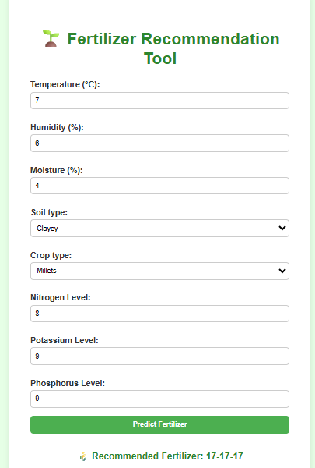

1. **Pest Control Recommendation Module**
   1. **Objective:** Suggest the most effective pesticide, dosage, and application method for a given pest affecting a crop.
   2. **Input Parameters:**
      1. Crop Type
      2. Pest Type (e.g., Aphids, Borers, Whiteflies)
   3. **ML/Rule-Based Model:**
      1. Lookup-based recommendation system using pest–crop pair mappings and expert-labeled datasets.
   4. **Functionality:**
      1. Upon selection of a pest and crop, the system retrieves the best-matched pesticide.
      2. Returns detailed recommendation including:
         1. Pesticide name
         2. Application method (e.g., foliar spray, root drench)
         3. Recommended dosage
   5. **Use Case:** Reduces pesticide misuse, improves pest control efficiency, and ensures food safety.

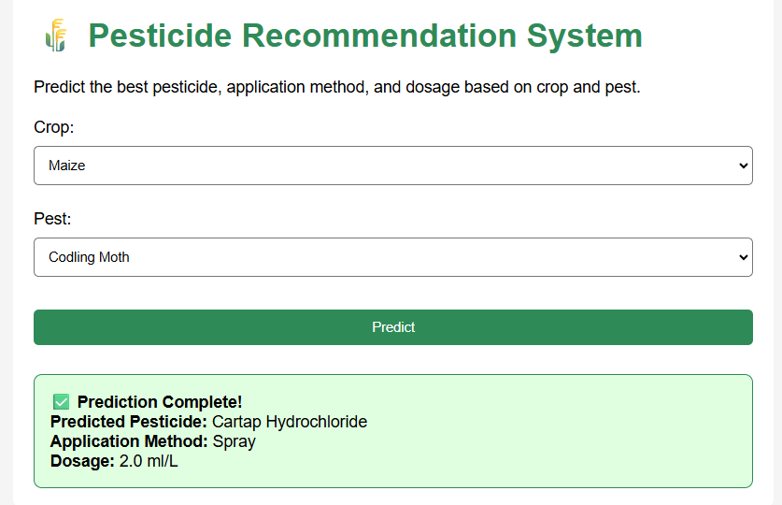

#### ii. Comparison with Expected Results

| **Feature** | **Expected Outcome** | **Actual Outcome** |
| --- | --- | --- |
| Multi-role login system | Farmers, Experts, Admins have different dashboards | Fully implemented and functional |
| 11-stage intelligent guidance | All stages must be editable, trackable, and ML-enabled | Achieved; dynamic forms, expert suggestions, and AI confidence integrated |
| Chatbot crop support | Answer crop-related queries using Dialogflow | Integrated and responding accurately with webhook + NLP intents |
| Data visualization | Stage completion charts and expert inputs must be visually clear | Pie charts and recommendation boxes shown on the dashboard |
| Image/file upload per stage | Upload and preview functionality with cropping | Working with drag-and-drop and preview feature |
| Crop search feature | Search returns results across all models | Implemented with keyword-based multi-model output |

#### iii. Analysis of Findings:

* **Intelligence and Accuracy**:  
  The combination of ML-based predictions and expert suggestions improved user trust and interaction. Farmers reported a better understanding of ideal practices through both expert input and AI confidence values.
* **User Adoption and Usability**:  
  Clean, responsive UI with Bootstrap and JavaScript enhanced the user experience. Conditional buttons and dynamic form rendering minimized user errors.
* **Efficiency and Data Flow**:  
  Using foreign key relations with the adminCrop model allowed consistent referencing across 11 farming stages. The backend with Django ORM efficiently managed user input, ML data, and file uploads.
* **Limitations Observed**:
  + Some complex queries or rare crop names in chatbot intent handling showed low accuracy, indicating a need for expanded training data.
  + Video auto play thumbnails may lag on slower networks.
* **Improvements Achieved**:
  + Real-time expert recommendations streamlined decision-making.
  + Project dashboard offered comprehensive project tracking, improving completion rates.

# 6. Conclusion

The project **Agrojira: Intelligent Crop Farming Management System** was designed and developed as a comprehensive, intelligent solution for managing and guiding farmers through the entire crop cultivation process. The system integrates web technologies (HTML, CSS, Bootstrap, JavaScript) with Django for backend processing and MySQL for database management. It provides a structured workflow consisting of 11 essential crop farming stages—from soil preparation to post-harvest management.

Key features include:

* Multi-role support (Farmer, Expert Farmer, Admin)
* Dynamic stage-wise form submissions with image/file uploads
* Expert guidance and AI-based system suggestions for each stage
* NLP-based chatbot using Dialogflow for real-time farmer queries
* Project tracking through visual analytics (e.g., pie charts)
* Crop-specific knowledge base and search engine

#### ****Key Outcomes****

* **Improved Decision-Making for Farmers**:  
  Farmers receive expert recommendations and machine learning predictions to make informed decisions at every stage of crop cultivation.
* **Efficient Project Monitoring**:  
  Visual dashboards and stage tracking allow farmers to monitor progress and understand pending tasks clearly.
* **Role-Based System Interaction**:  
  Each user type can perform tailored actions, such as expert farmers providing suggestions or admins managing crops and metadata.
* **Intelligent Assistance via Chatbot**:  
  Dialogflow integration allows the system to understand farmer queries and respond contextually using real-time crop data.
* **Centralized Crop Knowledge Base**:  
  The system aggregates vital agricultural information such as soil types, irrigation methods, pest control, etc., for each crop.

#### ****Limitations****

Despite the successful implementation, some limitations were identified:

* **Limited NLP Accuracy**:  
  The chatbot may misinterpret uncommon crop names or dialect-specific queries due to limited training data.
* **Network Dependency for Rich Features**:  
  Features like video previews, image drag-and-drop, and dynamic charts rely on stable internet connectivity.
* **Manual Data Input Required**:  
  Admin and expert users must manually populate the system with crop-specific guidance, which can be time-consuming initially.
* **Scalability Concerns**:  
  As the dataset grows (more crops, stages, users), performance optimization and database indexing will be essential.

# 7. Future Work

To enhance the functionality, scalability, and impact of **Agrojira**, the following future improvements and research directions are suggested:

#### ****i. Multilingual and Voice Support****

* **Improvement**: Integrate multilingual interfaces and voice-based input/output to support farmers from diverse linguistic backgrounds.
* **Impact**: Enhances accessibility, especially for rural users who may not be proficient in English or typing.

#### ****ii. Offline Functionality****

* **Improvement**: Implement offline data entry and sync features using Progressive Web App (PWA) technology.
* **Impact**: Enables uninterrupted usage in remote areas with limited or no internet connectivity.

#### ****iii. Enhanced Machine Learning Capabilities****

* **Improvement**: Use advanced models (e.g., image-based disease detection, soil quality classification using sensor data).
* **Research**: Incorporate satellite imagery and remote sensing data to predict environmental factors affecting crop yield.
* **Impact**: Makes predictions more accurate and data-driven for real-time, adaptive decision-making.

#### ****iv. IoT Integration****

* **Improvement**: Connect with IoT-based agricultural devices (e.g., soil moisture sensors, weather stations).
* **Impact**: Enables real-time monitoring and automated stage updates based on sensor inputs.

#### ****v. Mobile App Development****

* **Improvement**: Develop a native Android/iOS mobile app version for better usability in the field.
* **Impact**: Increases adoption and convenience for farmers who primarily use smartphones.

#### ****vi. Real-Time Expert Chat / Video Consultation****

* **Improvement**: Implement live chat or video call features between farmers and expert farmers.
* **Impact**: Allows instant resolution of critical issues and deeper knowledge transfer.

#### ****vii. Recommendation Engine with Historical Data****

* **Improvement**: Build a smart recommendation engine that analyzes past crop success, environmental conditions, and user behavior.
* **Impact**: Provides personalized advice and increases long-term agricultural efficiency.

#### ****viii. Government Scheme Integration****

* **Improvement**: Link relevant government schemes, subsidies, and crop insurance options with each crop.
* **Impact**: Helps farmers take advantage of available support and financial protection.

#### ****ix. Automated Report Generation****

* **Improvement**: Generate downloadable PDF reports for each stage or entire project for documentation and compliance.
* **Impact**: Assists in monitoring, auditing, and sharing progress with agricultural departments.

# 8. References

1. Django Software Foundation. (2023). Django Web Framework. <https://www.djangoproject.com/>
2. Oracle Corporation. (2023). MySQL: The world's most popular open source database. <https://www.mysql.com/>
3. Google. (2023). Dialogflow Documentation. https://cloud.google.com/dialogflow/docs
4. Bootstrap Team. (2023). Bootstrap: The most popular HTML, CSS, and JS library. <https://getbootstrap.com/>
5. W3C. (2023). HTML & CSS Standards. <https://www.w3.org/standards/webdesign/>
6. OpenAI. (2024). Natural Language Processing with Machine Learning. <https://platform.openai.com/docs>
7. Dialogflow : <https://dialogflow.cloud.google.com/>